  The Sega's both systems had almost exactly the same hardware with the only difference being that one was mobile and the other handheld. That enabled game developers to easily transfer games from one system to another.
  Specs:
  Master System  - Bits (CPU) (8): 8 Bits  - (Gx): 8  - CPU: Z80  - MHz: 3.6  - Graphics: 240 x 226  - Colors Available: 256  - Colors on screen: 52  - Sprites: 16  - Sprite size: 8x8  - Audio: Mono  - RAM: 64Kbits |  | Game Gear  - Main Processor: Z-80 (8-bit)  - Processor Speed: 3.58 MHz  - Resolution: 160 x 146  - Colors Available: 4,096  - Colors on screen: 32  - Maximum Sprites: 64  - Sprite Size: 8x8  - Screen Size: 3.2 Inches  - Audio: 4-lyr  - RAM: 24K
  Screenshots
  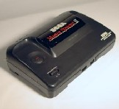
  Sega Master System
  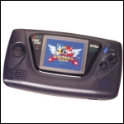
  Sega Game Gear

